RESIDENT COMPLAINT & ISSUE BOARD
@CREATIVITY THINK (9483175986/7019689991)

ABSTRACT:
Resident Complaint & Issue Board is a dynamic web application designed to streamline issue reporting and resolution within residential communities such as apartments, gated colonies, and campus housing. The system enables residents to post complaints with photos, categorize issues, track status updates, vote on common problems, and communicate via comments. Administrators can assign issues to staff, merge duplicates, manage statuses, and view analytics such as heatmaps and category-wise reports. With Django REST Framework powering the backend and React handling the user interface, this platform ensures a fast, organized, and transparent complaint-management workflow..

INTRODUCTION OF THE PROJECT:
Managing complaints in residential areas is often complex due to inefficient manual processes, lack of tracking, and communication gaps between residents and management. Traditional methods like WhatsApp groups, emails, or paper logs fail to provide transparency and analytics.
The Resident Complaint & Issue Board provides a centralized digital platform where residents can submit complaints, monitor status changes, and interact via comments. Admin staff can easily categorize issues, assign them to maintenance teams, and ensure timely resolution. The built-in analytics dashboard helps management understand trends and improve service quality..

PROJECT OBJECTIVES:

• Enable residents to post issues with category tags and photo attachments
• Provide real-time status tracking (Open → In-Progress → Resolved)
• Allow comments and upvotes on shared or common issues
• Notify residents about updates or resolutions
• Allow administrators to categorize and assign issues to staff
• Support merging duplicate complaints for efficiency
• Offer analytics such as heatmaps, category-wise counts, and resolution performance
• Provide history logs and monthly downloadable reports
• Improve transparency and accountability across the complaint cycle

PROBLEM OF THE STATEMENT:
Residential communities often face recurring issues like water leakage, electricity outages, and security concerns. Without a centralized tracking mechanism, these problems remain unresolved or unnoticed. The absence of analytics prevents administrators from identifying patterns or bottlenecks. This project solves the problem by offering a comprehensive tracking and analytics system that ensures quick action, transparency, and structured communication between residents and management..

MOTIVATION OF THE PROJECT:
• To provide a transparent and organized solution for community issue management
• To ensure residents feel heard and updated regarding their complaints
• To replace unstructured manual complaint methods
• To assist management with data-driven insights
• To reduce duplicate complaints using tagging and merging
• To improve maintenance staff efficiency through assignments and tracking
• To enhance community experience through structured digital workflows

BLOCK DAIGRAM OF PROJECT:

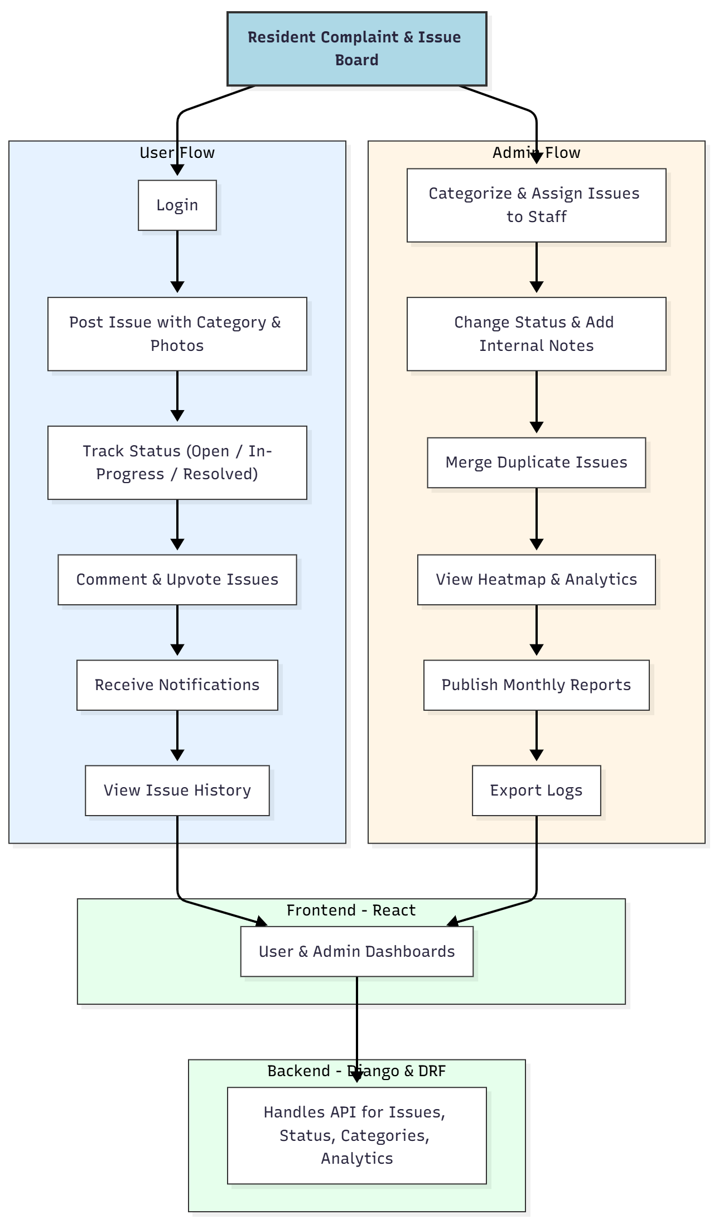

WORKING OF THE PROJECT:
Residents log in to the platform and post complaints, selecting categories such as water, electricity, housekeeping, or security. They can upload photos and describe the issue. The system notifies admins, who then categorize and assign the problem to relevant staff.
Users can track the live status of their issues, vote on commonly faced problems, and interact through comments.
Admins can merge similar complaints, update progress, and add internal notes. The dashboard displays analytics like issue distribution, daily logs, and heatmaps based on blocks or categories.
Finally, administrators can publish monthly reports and export detailed logs for documentation..

SOFTWARE REQUIREMENT:
- Backend:
  - Python 3.x
  - Django
  - Django REST Framework
  - SQLite/PostgreSQL
- Frontend:
  - Node.js and npm
  - React.js
  - Axios
- Development Tools:
  - Visual Studio Code
  - Postman (for testing APIs)
  - Git/GitHub (for version control)
- Server/Deployment (Optional):
  - Gunicorn, Nginx, or Heroku/AWS for hosting

ADVANTAGES OF THE PROJECT:

• Provides transparency between residents and management
• Faster complaint resolution due to structured workflows
• Easy communication via comments and notifications
• Prevents redundancy through issue merging
• Offers real-time data analytics for decision-making
• Increases accountability among staff and management
• Enhances resident satisfaction and trust

APPLICATIONS OF THE PROJECT:
• Apartment complexes
• Gated communities
• University and college hostels
• Corporate housing campuses
• Residential colonies
• Government residential quarters

REFERENCES:

- Django REST Framework Documentation — Django Software Foundation. Django Documentation. Available: https://docs.djangoproject.com/
- Django REST Framework. DRF Documentation. Available: https://www.django-rest-framework.org/
- React. React Official Documentation. Available: https://reactjs.org/docs/getting-started.html
- Redux. Redux Documentation. Available: https://redux.js.org/introduction/getting-started
- PostgreSQL Global Development Group. PostgreSQL Documentation. Available: https://www.postgresql.org/docs/
- MySQL. MySQL Reference Manual. Available: https://dev.mysql.com/doc/
- Git. Git Documentation. Available: https://git-scm.com/doc
- Node.js. Node.js Documentation. Available: https://nodejs.org/en/docs/
- Axios. Axios Documentation. Available: https://axios-http.com/docs/intro
- Socket.io Documentation – https://socket.io/docs/

